BENJIE JERALD AMATOSA
MIDTERM ACTIVITY NO.2 - MODIFYING TABLES AND INSERTING RECORDS
CREATE TABLE
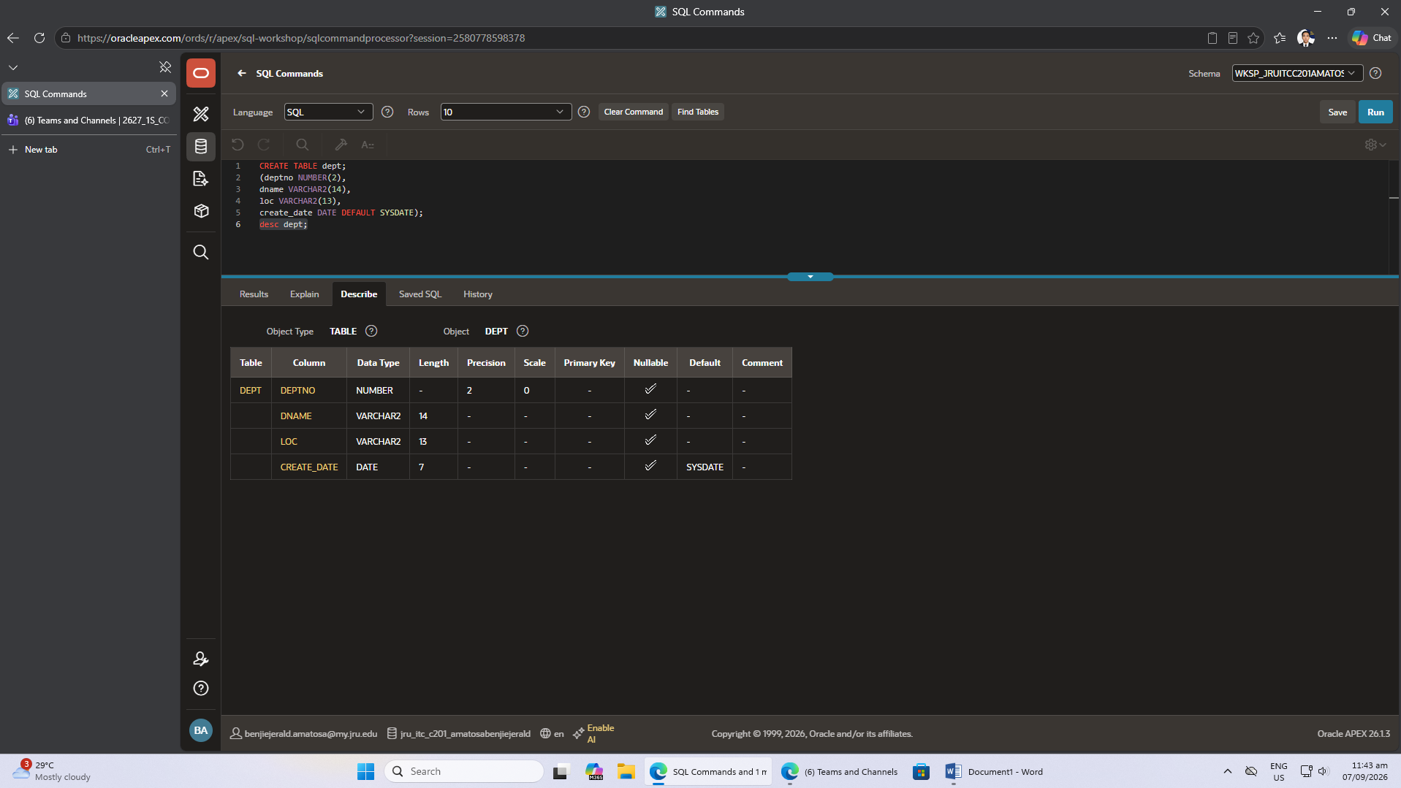
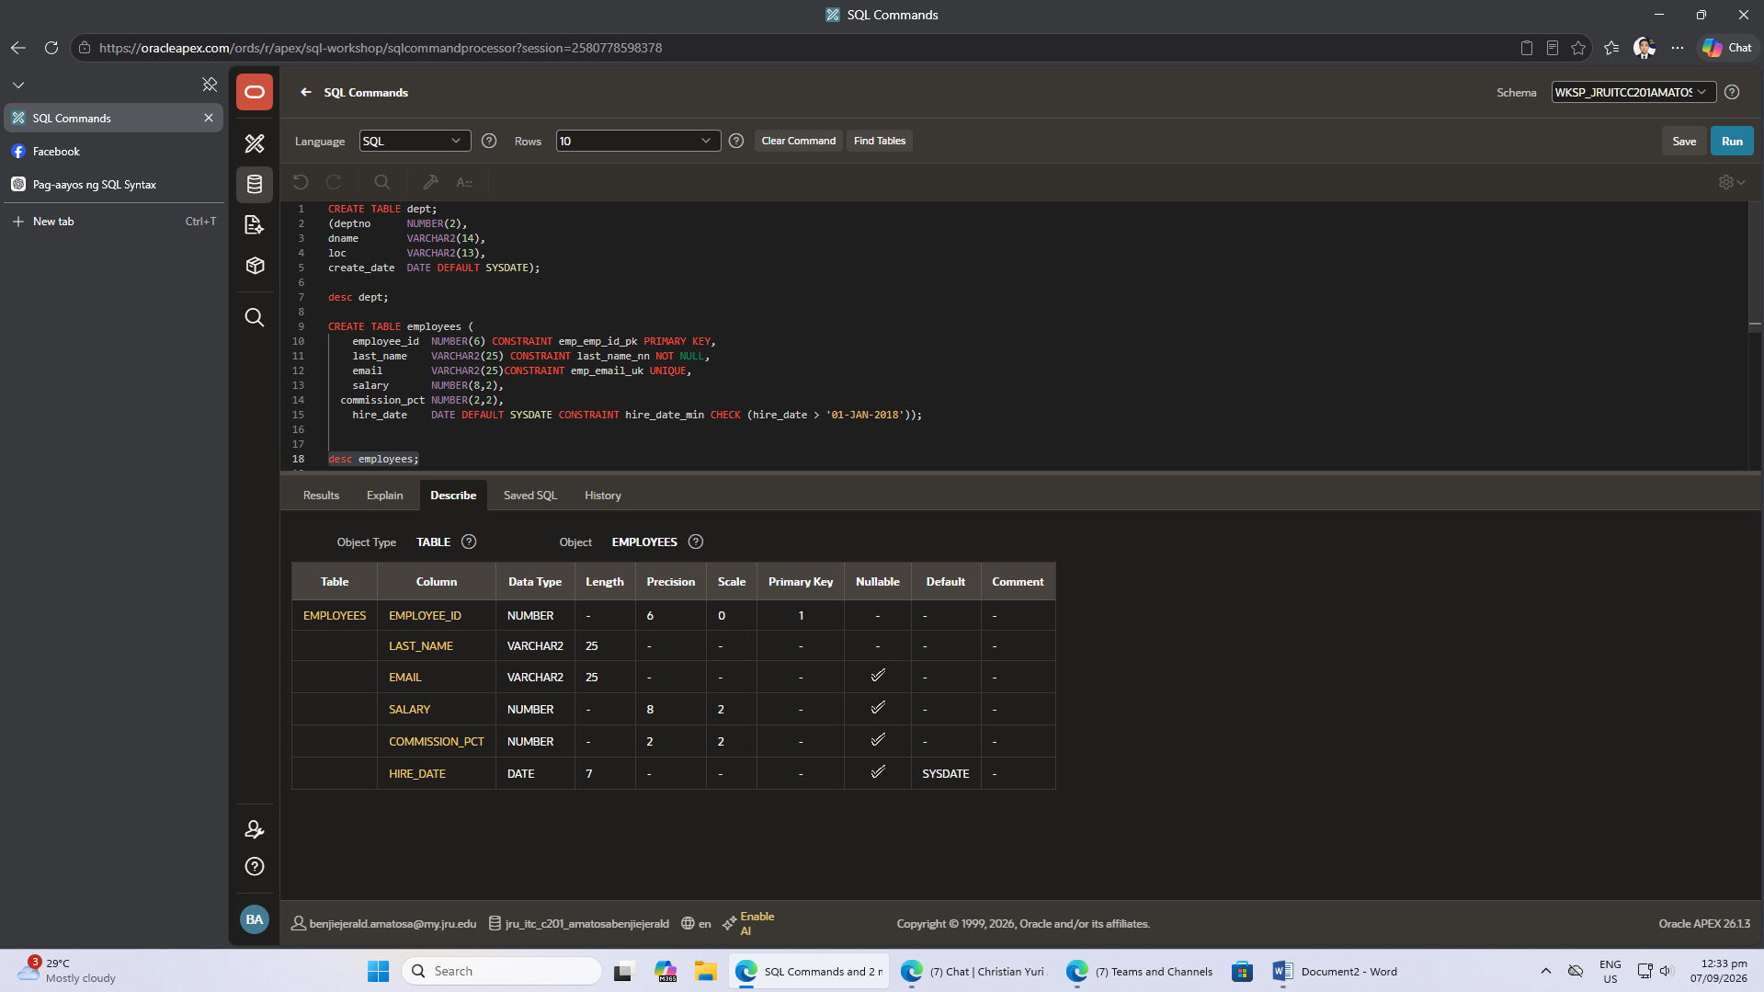

ALTER TABLE dept
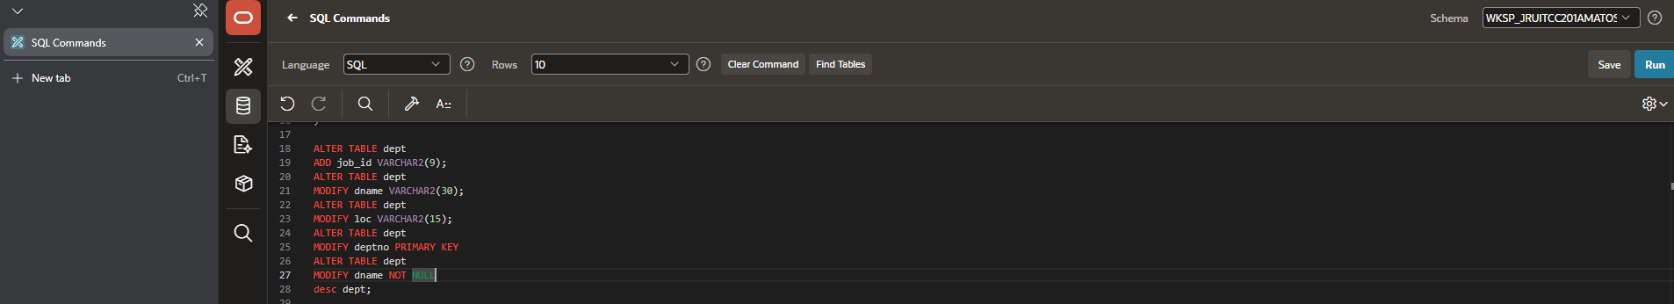

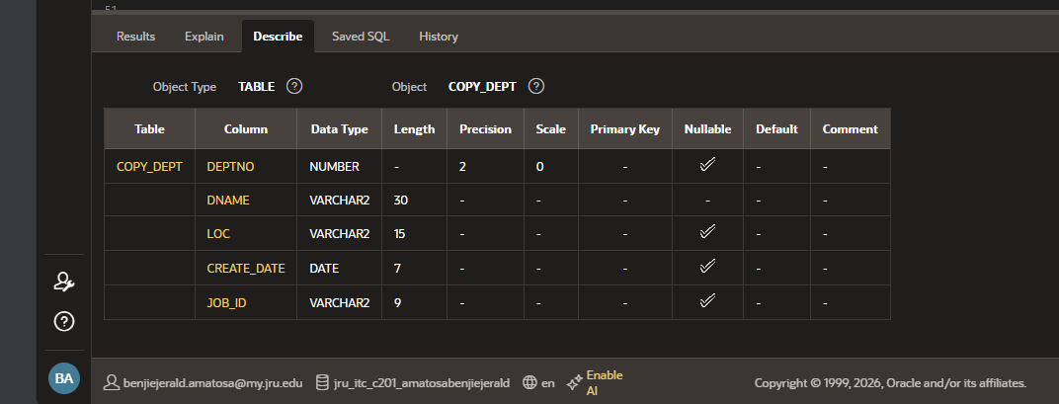

ALTER TABLE employees

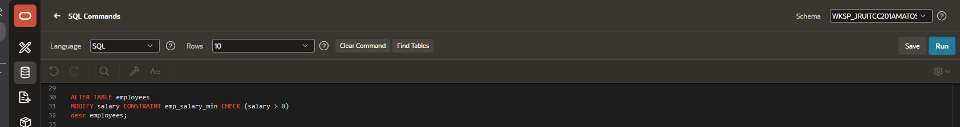 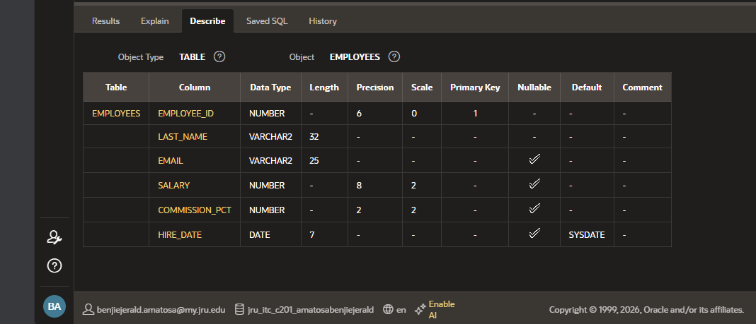
INSERT


